ANNUAL CONSIGNMENT SALE

ACCEPTING PROM & PAGEANT GOWNS

DROP OFF DATES

December 5-9, 2022

December 12-17, 2022

December 19-22, 2022

Appointment required for drop off

Book appointment on:

Scan the QR CODE

website: imagespromandpageant.com

Instagram: @imagesformalwear

SALE DATES

January 2023 Every Saturday

February 2023 Every Saturday

March 2023 Every Saturday

April 1, 2023

April 8, 2023

April 15, 2023

April 22, 2023
HOW IT WORKS
- Gowns purchased at Images:
Consignor pays Images a non-refundable display fee of $15.00 cash only per gown. (This category is for those gowns purchased by original owner at Images and does not include gowns purchased in our consignment sale.)

- Gowns not purchased at Images:
Consignor pay Images a non-refundable display fee of $20.00 cash only per gown.

- No gown will be accepted without display fee. Remember display fee is $15.00 or $20.00 per gown and you must pay cash. No debit or credit cards accepted.
- Download the Consignment Form & Contract. Fill them out and bring them with your gown.
- Once your gown has been accepted, it is placed on Images showroom floor for the months of January through mid-April.
- If the consignor’s gown sells, the consignor will receive a call to pick up a check.
- Gowns purchased at Images:
The consignor pays Images 20% of total sale for selling your gown. The consignor receives 80% of sale.

- Gowns not purchased at Images:
The consignor pays Images 25% of total sale for selling your gown. The consignor receives 75% of sale.

- The consignor determines the selling price of gown.
- The consignor determines to accept cash, check, or credit card.
- If credit card is used, the purchaser agrees to reimburse Images for credit card fee (3.5% of sale).
- Once your gown is consigned, it must remain with Images for the duration of the sale (i.e. until April 22, 2023). Any gown removed prior to April 22, 2023, the consignor agrees to pay Images the seller’s fee.

GOWNS MUST MEET THE FOLLOWING CRITERIA:
- Must have been purchased from Images or must be designer gowns (i.e. Jovani, Blush, Sherri Hill, Johnathan Kayne, etc.)
- No department store gowns or David’s Bridal gowns will be accepted
- Must have been purchased during the past 5 seasons
- Must be professionally cleaned or New with Tags
- Cannot have rips or tears
- No stains, spots, or yellowing
- Buttons, beads, lace must all be attached
- Zippers in good condition (zips, aligns)
- Odor Free (no smoke, perfume or other smells)
- Gowns must be on dress hangers. No wire hangers.

Example of hanger:
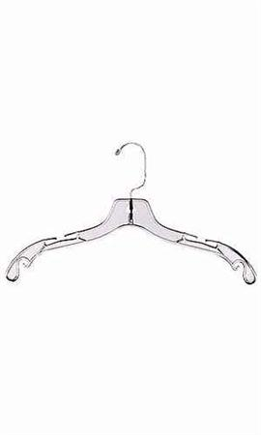

Prepare your garment tag with following information:
- Use a 4X6 index card turned vertically
- Your consignor # (your initials and the last 4 numbers of your cell phone)
- Purchase Price
- Brand, Size, Color
- Payment type you will accept:
- CA (cash) CK (check) CC (Credit Card)
Example of index card:
WC1234

$250.00
Sherri Hill
Red
Size 2

CA, CK, CC

Unsold gowns must be picked up by April 22, 2023. Any gowns left will be taken to Goodwill or donated to charity. No exceptions.

Guidelines for Shopping

• APPOINTMENT ONLY - NO WALK INS

• 3 ways to book appointment:

Website: imagespromandpageant.com
Instagram: @imagesformalwear
Scan the QR CODE

- Arrive to appointment on time. If you are more than 10 minutes late, you will need to reschedule.

- Appointments are 45 minutes.

- Parties will be limited
No more than 4 in your party

- A limit of 4 gowns per appointment for try on.

Once your appointment is made it is only for the Consignment Sale. You will not be allowed to go between the Consignment Sale and Images main floor unless you have scheduled an appointment for both.

Our goal is to keep everyone safe. These gowns are disinfected between appointments. Please be patient with us. We want to protect you and ourselves as well.

